**FREE – 7 DAY MASTER CLASS**

**AWS PROJECT**

**FACE DETECTION APP ON AWS**

**Name : Semmalar L**

**Reg no: 16MIS0125**

**College : VIT University, Vellore**

**Screenshots**

**SCREENSHOTS NEEDED FOR DASHBOARDS**

**AWS Login screen with username**

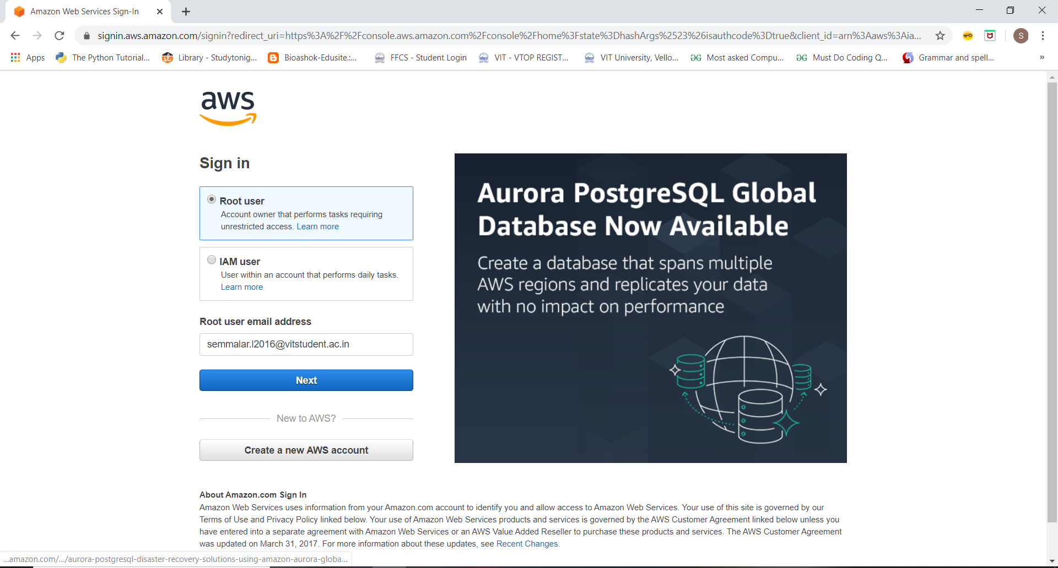

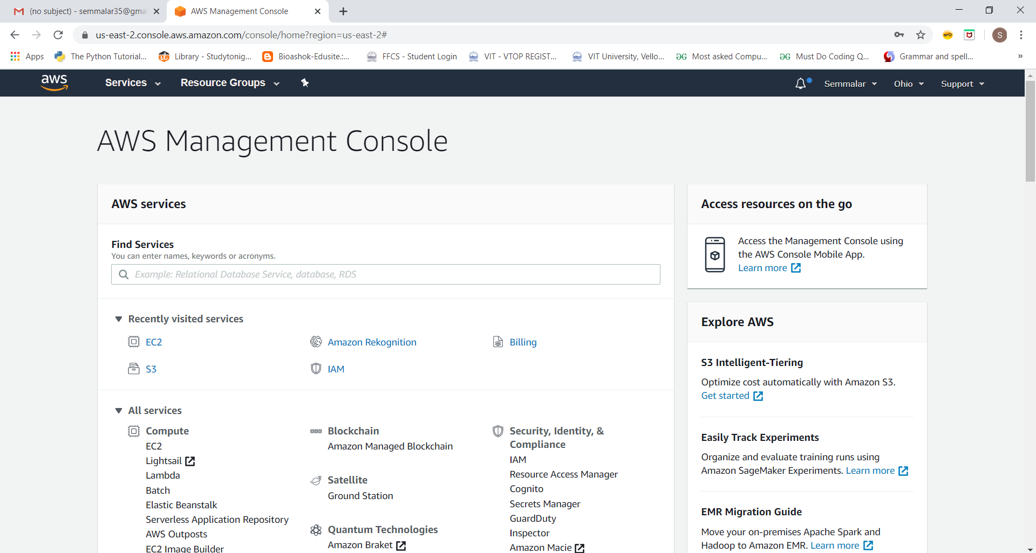

**EC2 Dashboard**

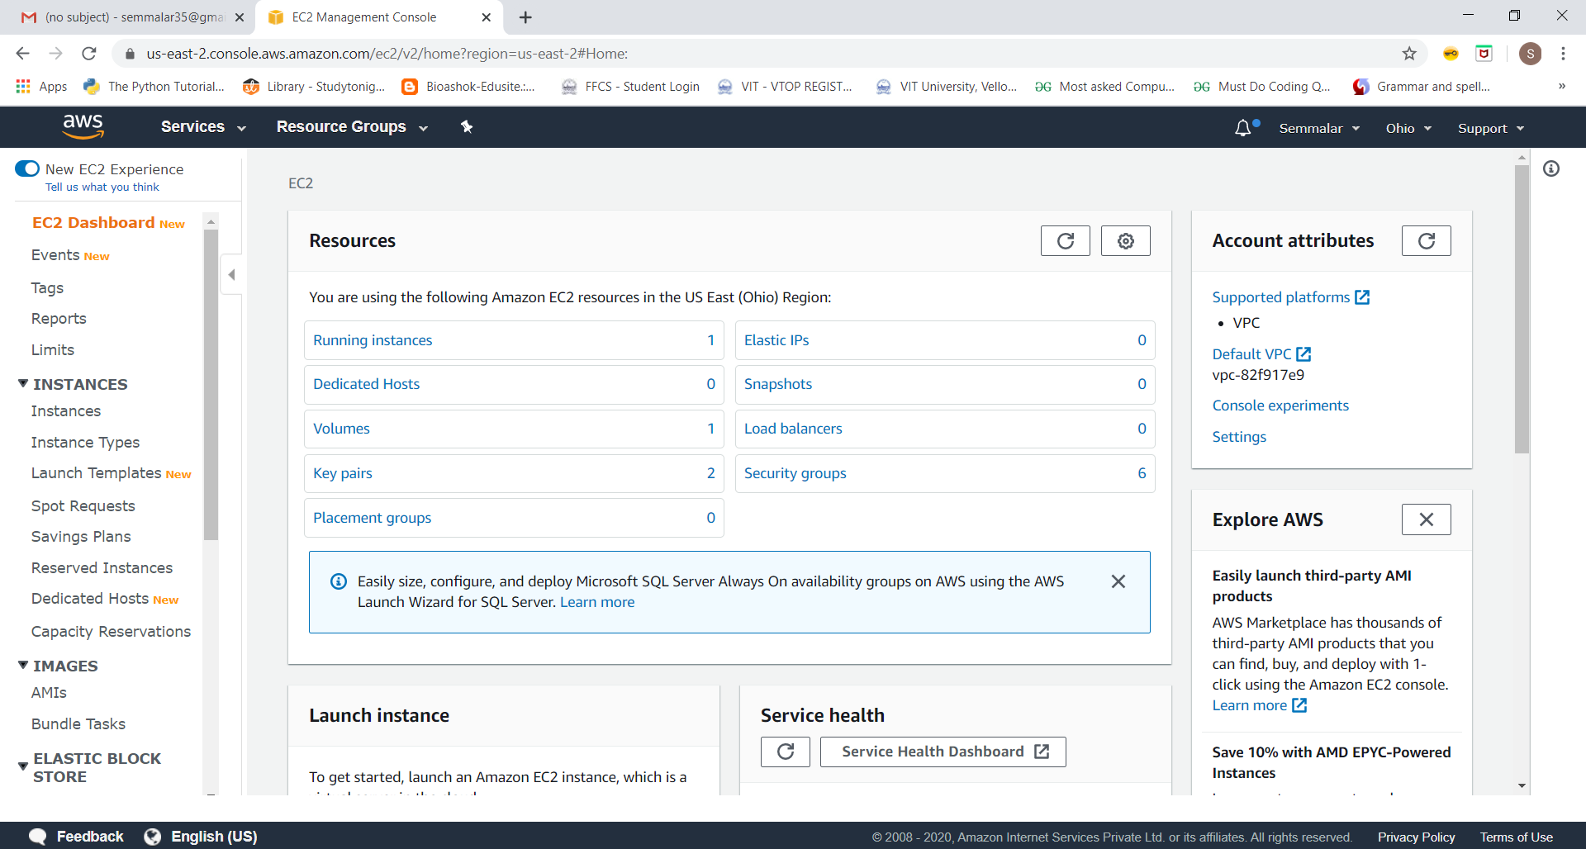

**S3 Dashboard**

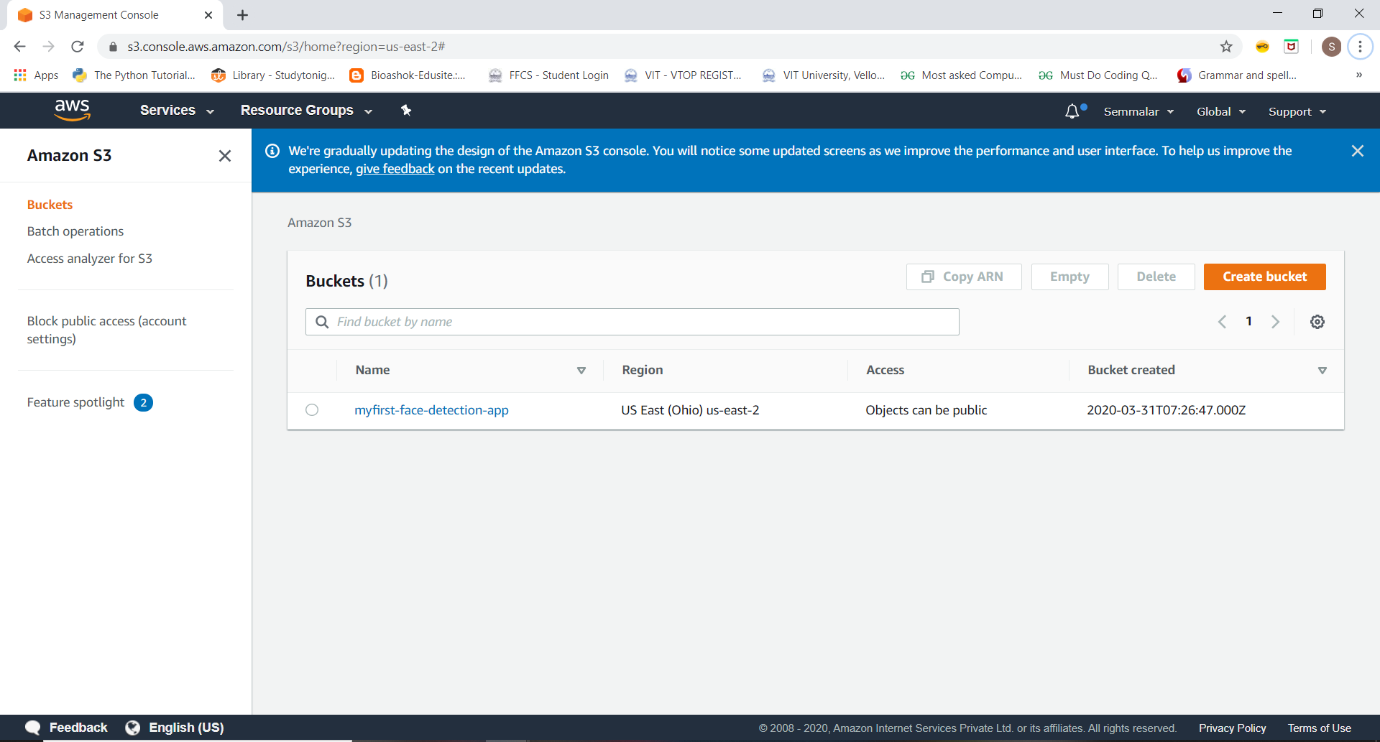

**Rekognition Dashboard**

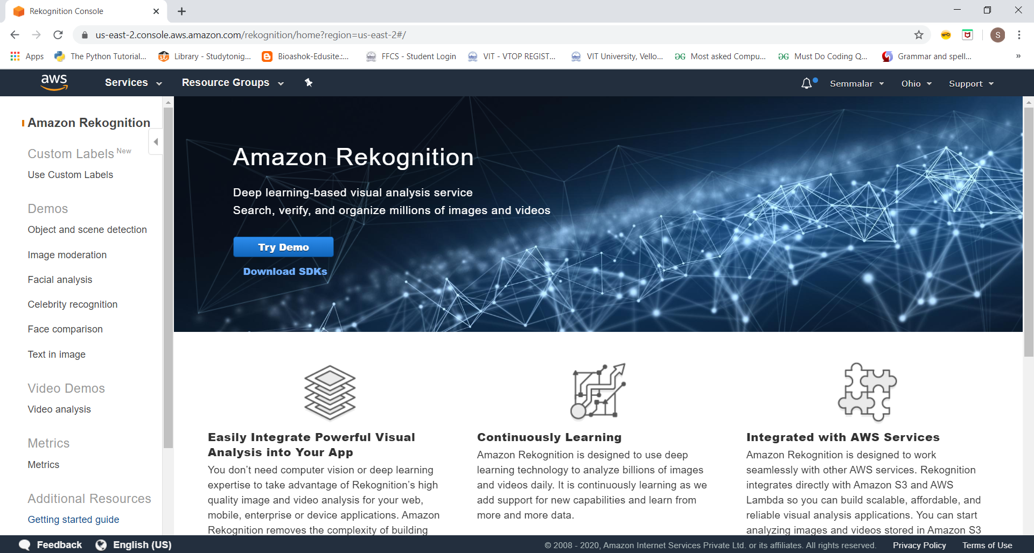

**SCREENSHOTS NEEDED FOR EC2**

**Choosing an AMI**

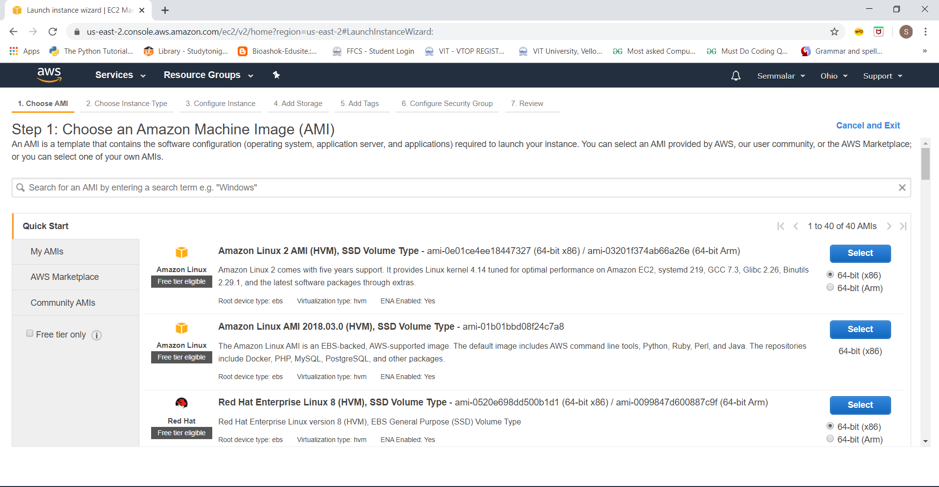

**Choosing an Instance Type**

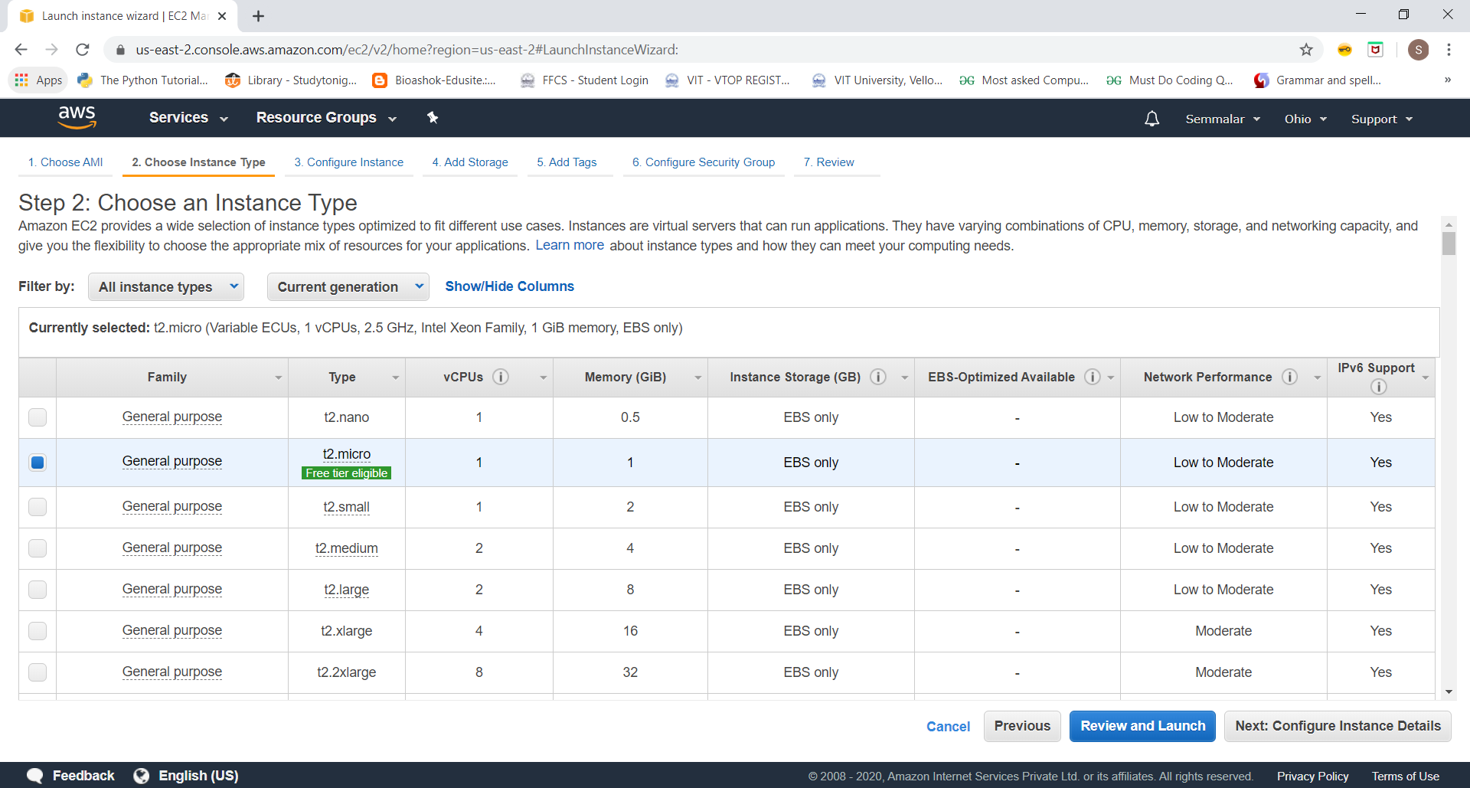

**Adding Storage**

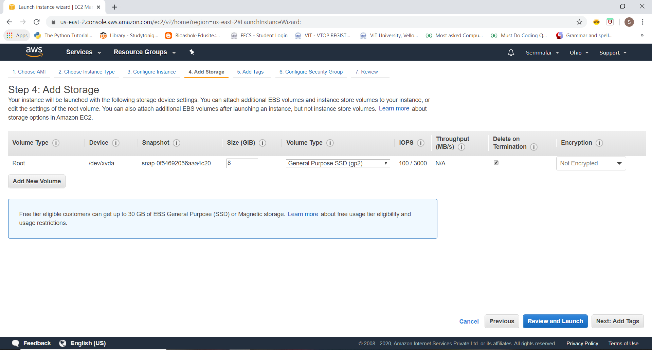

**Conﬁguring Security Group**

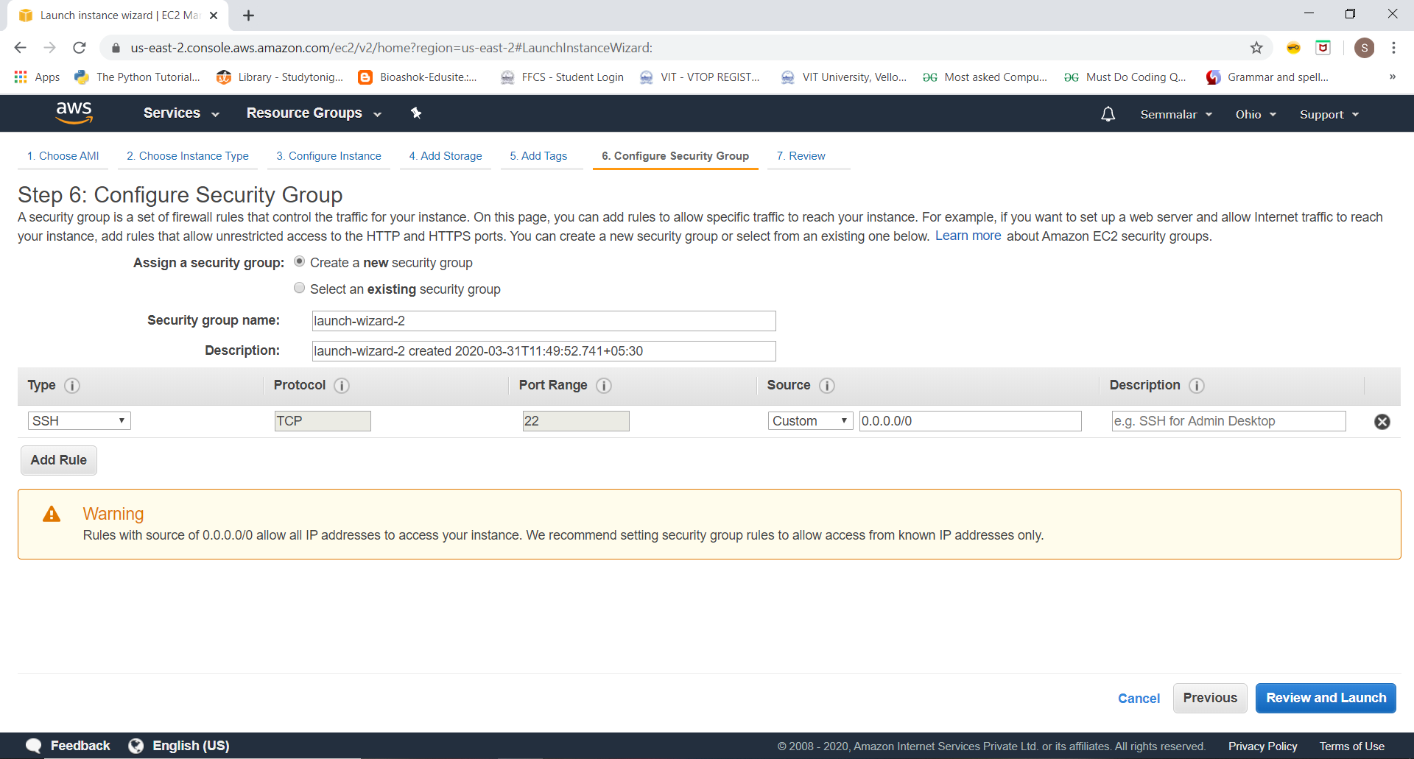

**Key Pair Download**

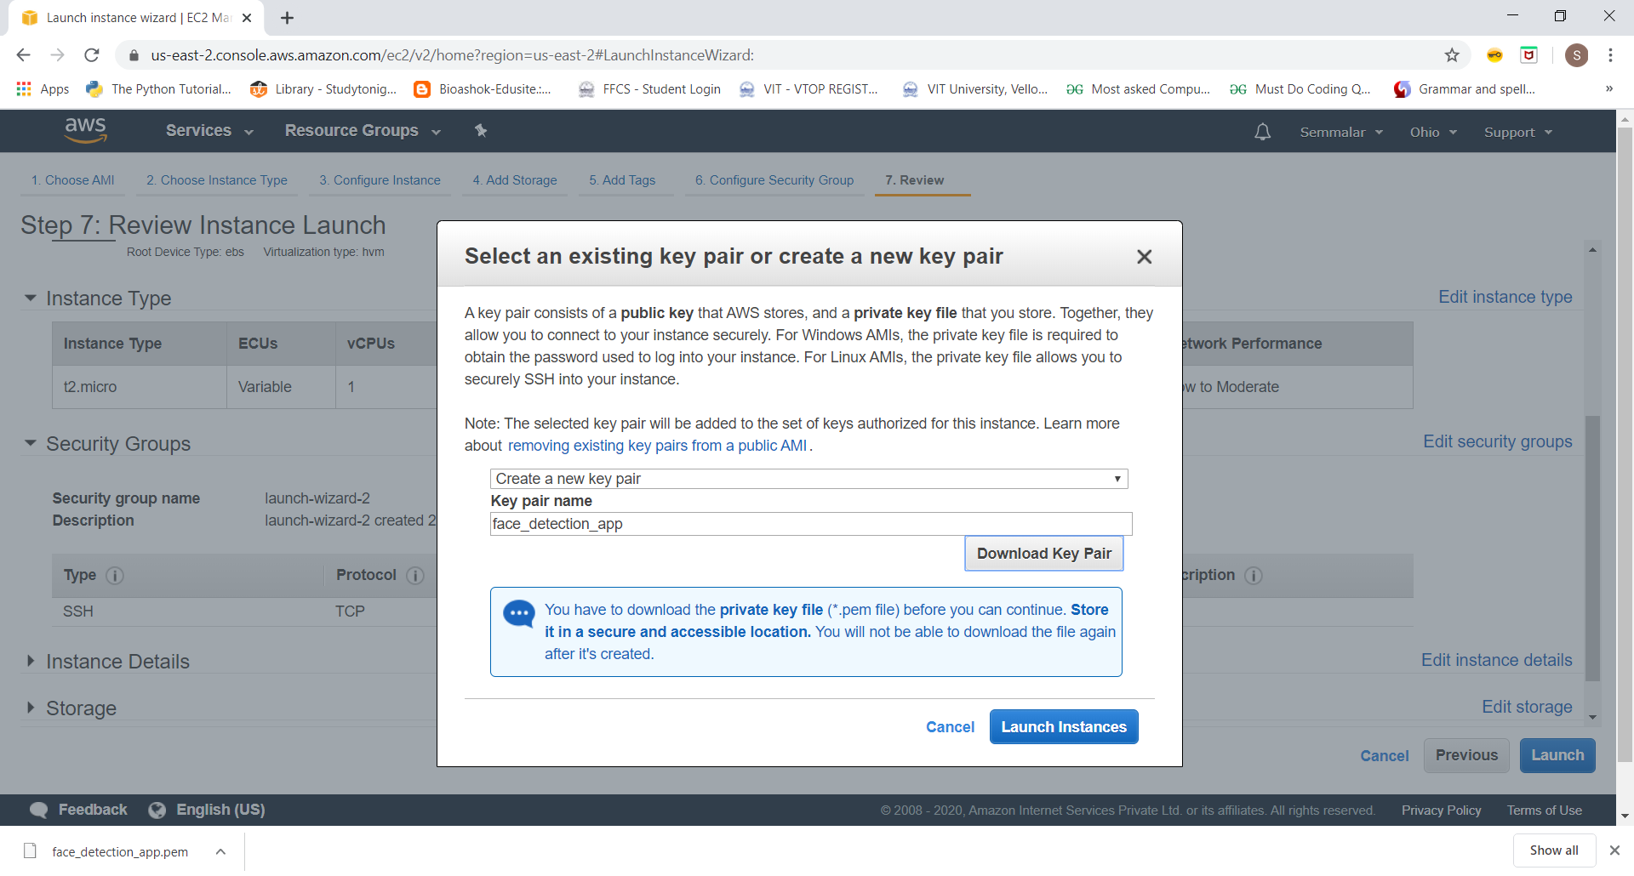

**PuTTYgen conversion from pem to ppk**

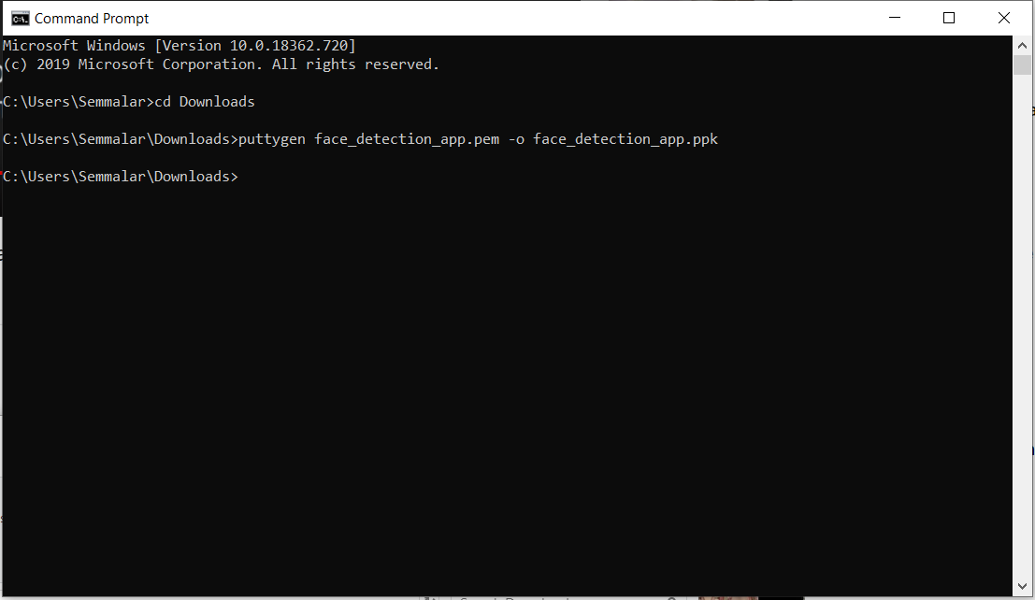

**Logged in EC2 black screen**

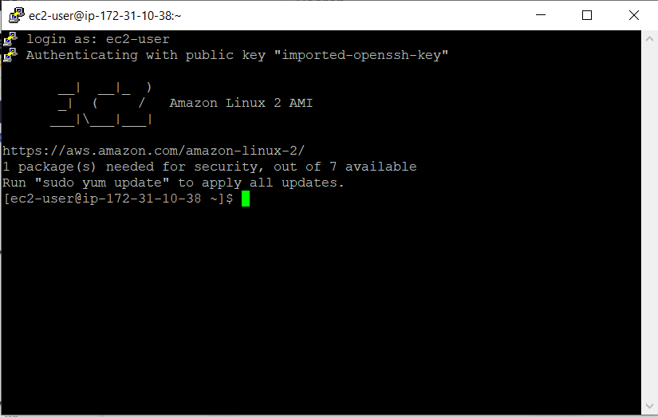

**SCREENSHOTS NEEDED FOR S3**

**Creating a bucket**

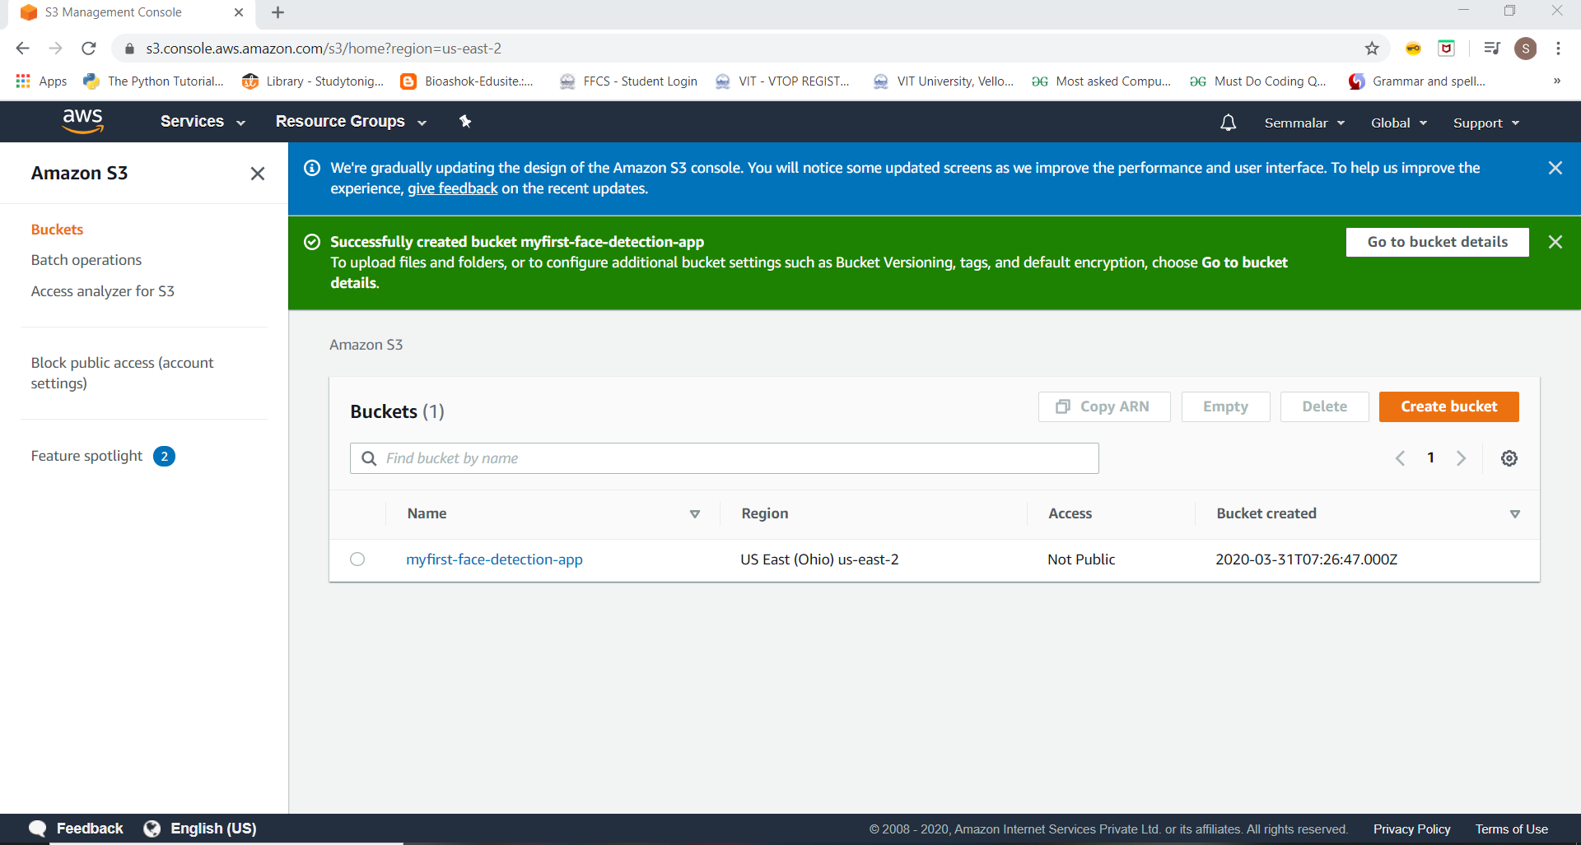

**Uploading an Object**

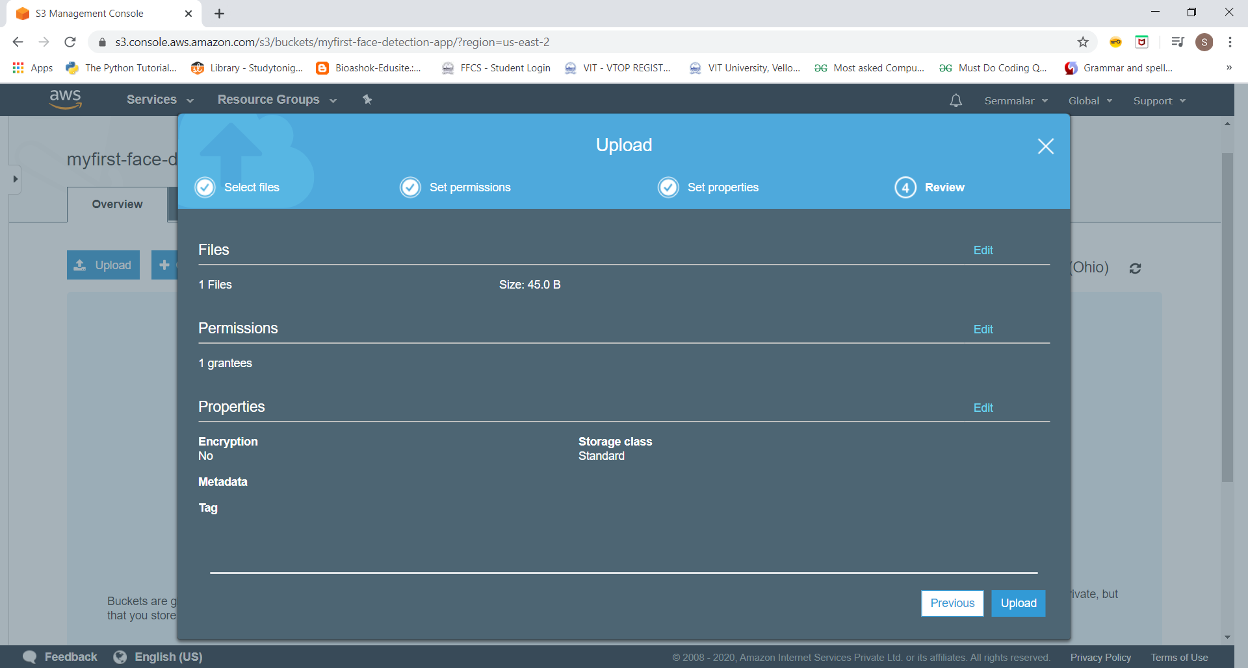

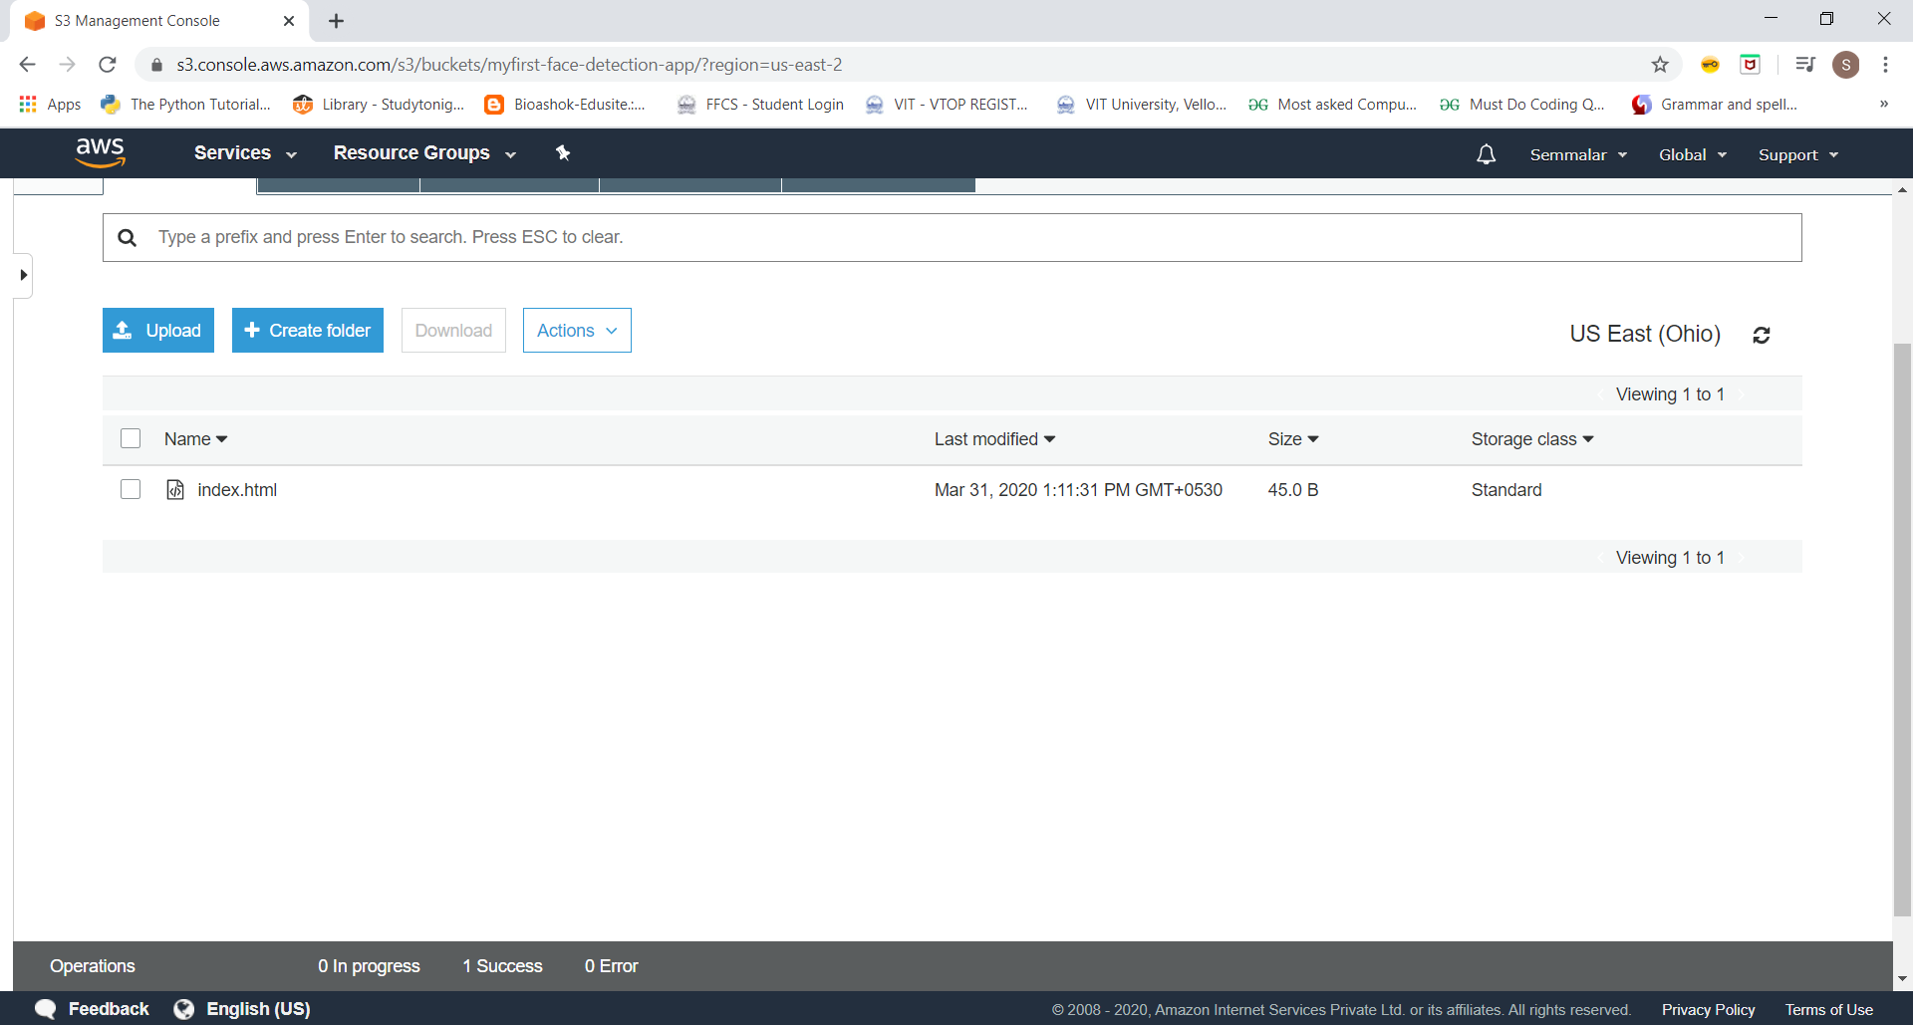

**Enabling Static Website**

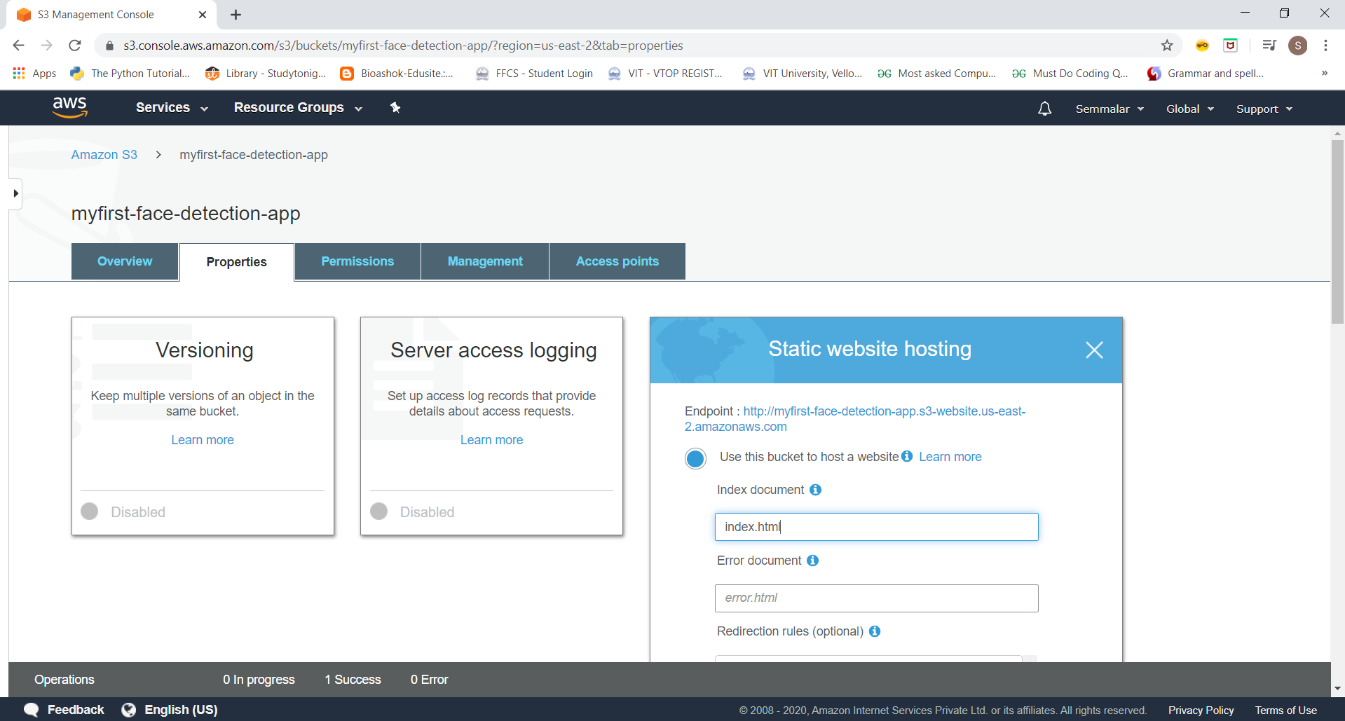

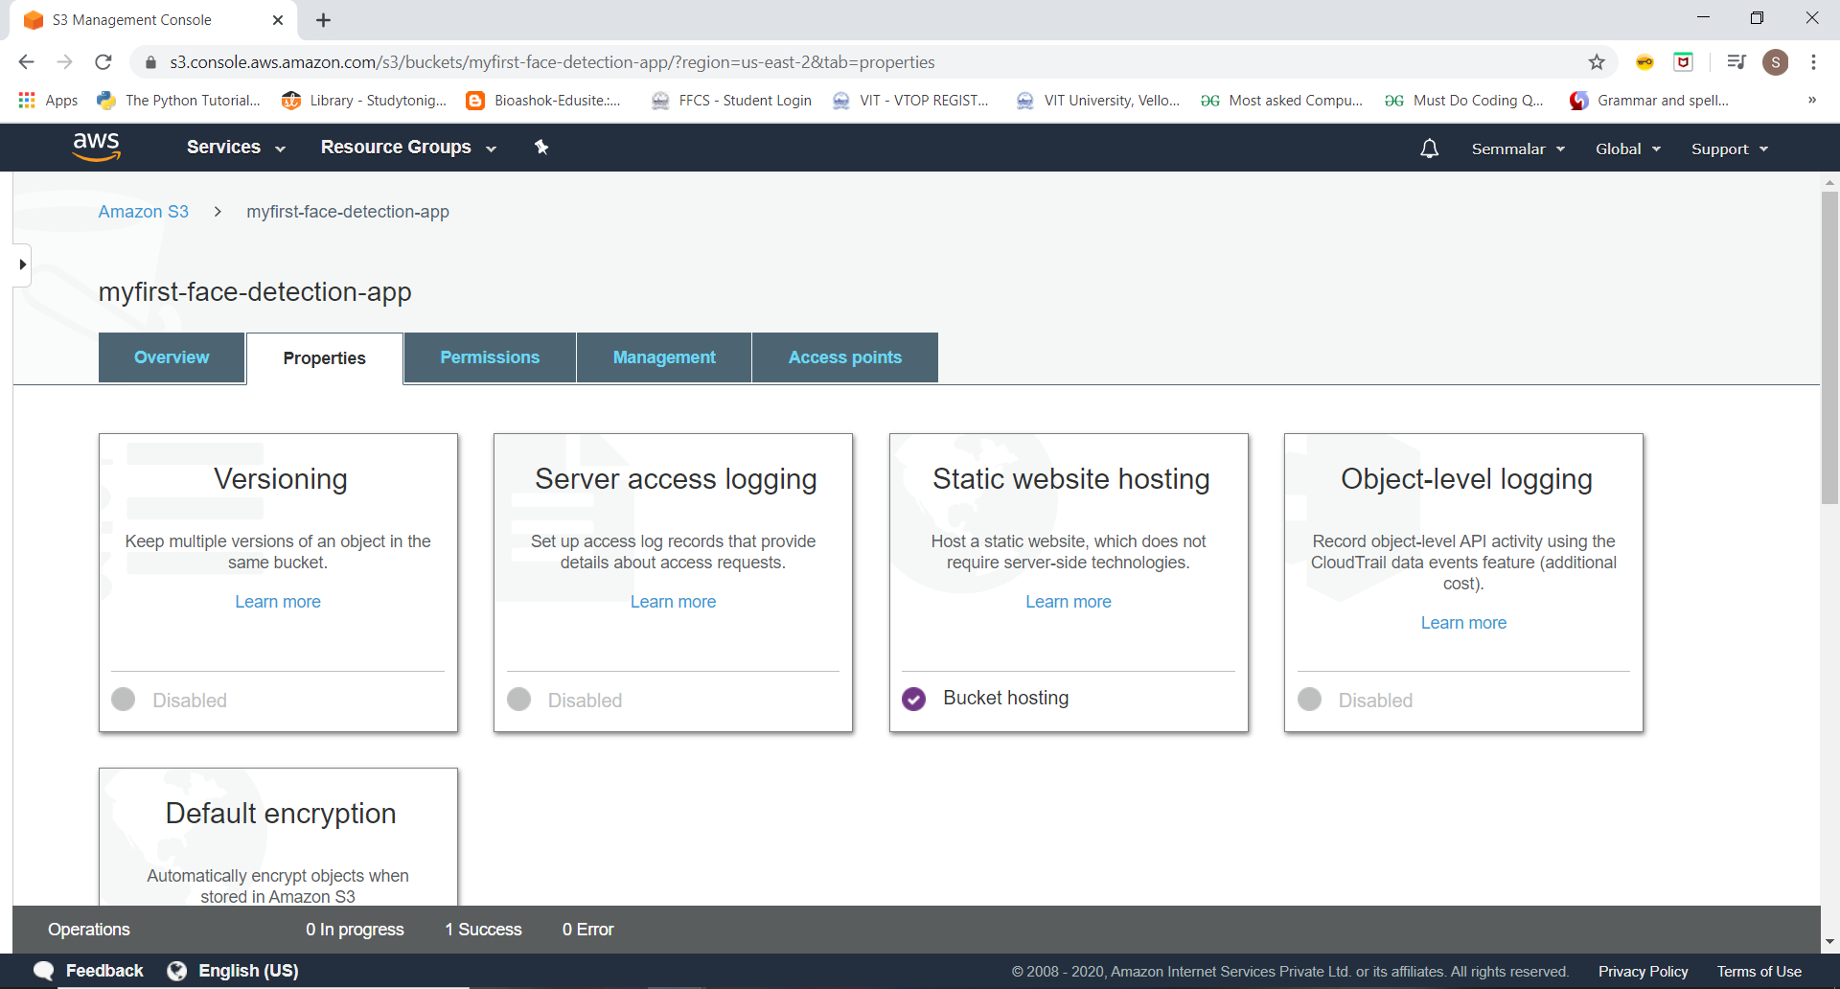

**Making the Object Public**

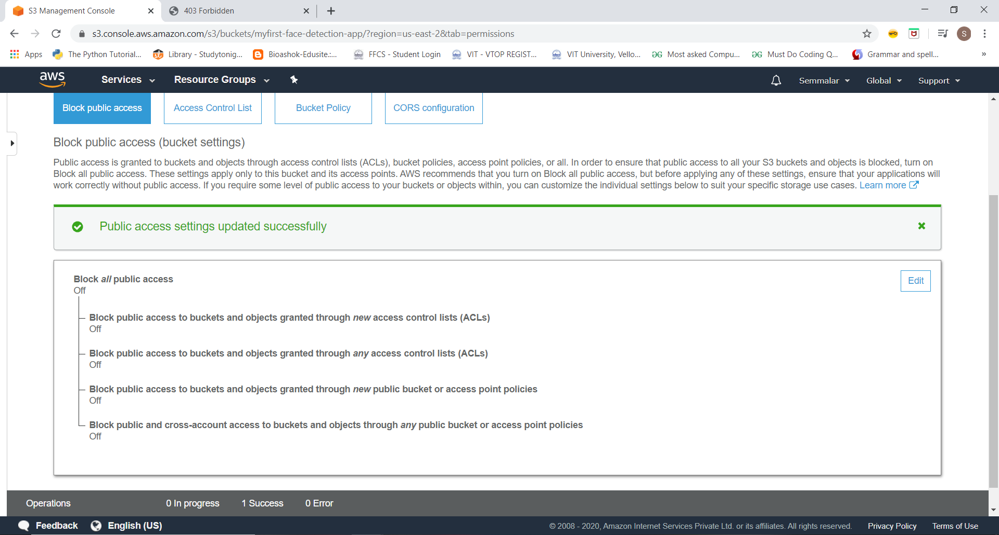

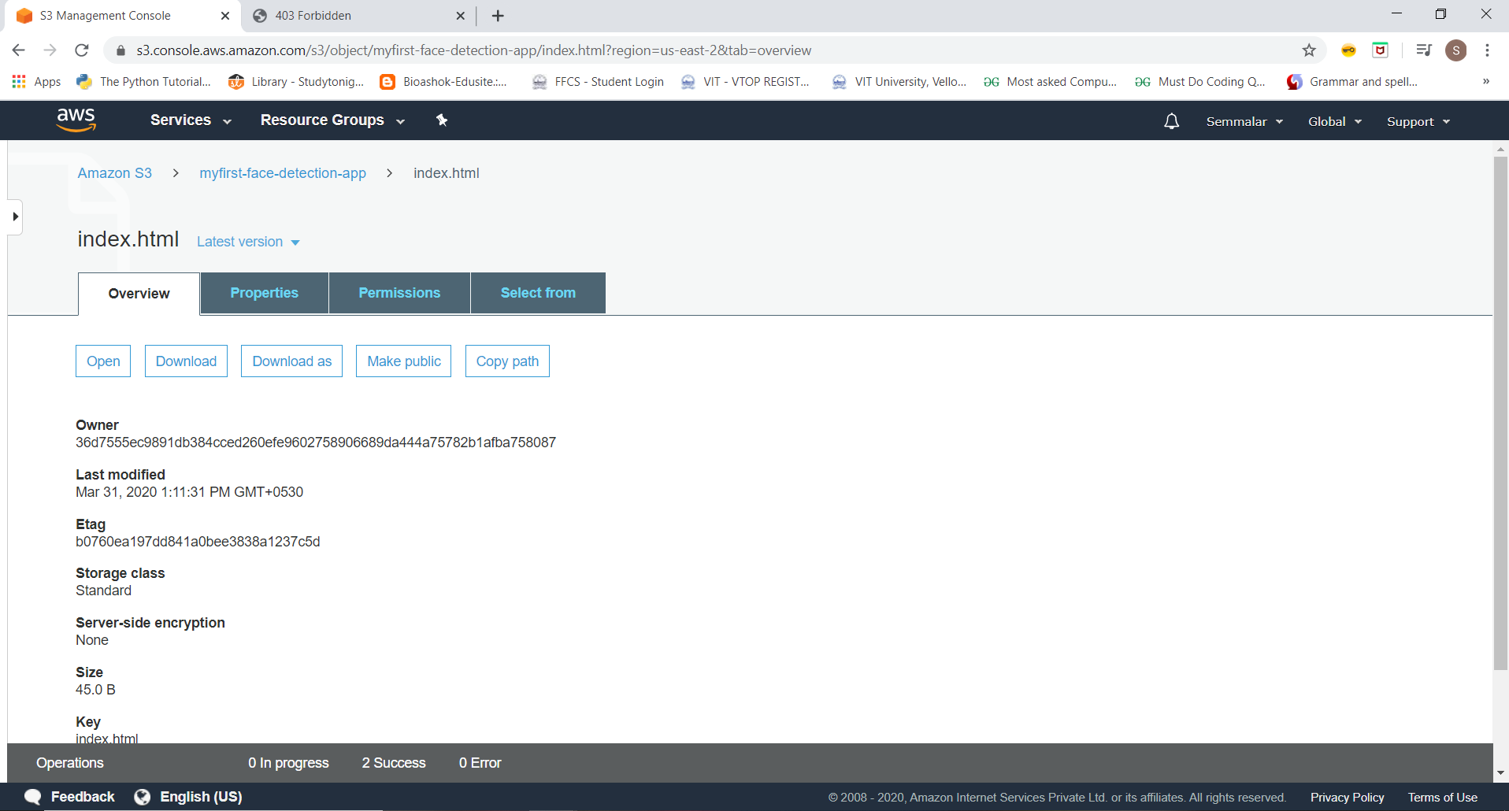

**Checking the S3 link on the browser**

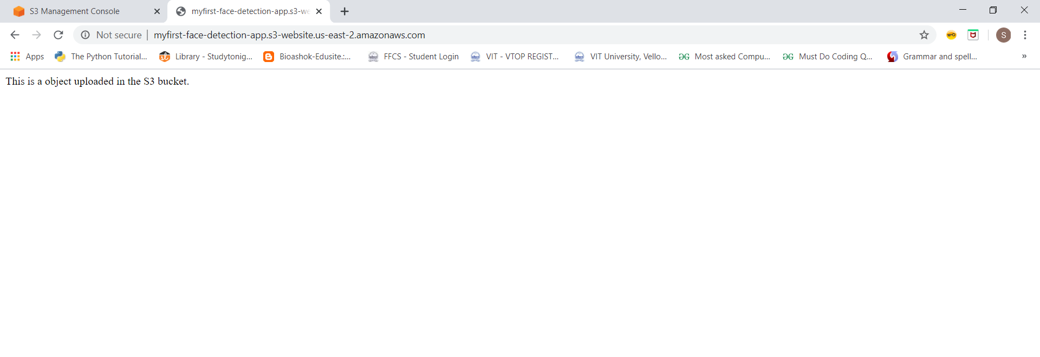

**SCREENSHOTS NEEDED FOR REKOGNITION**

**Face Detect**

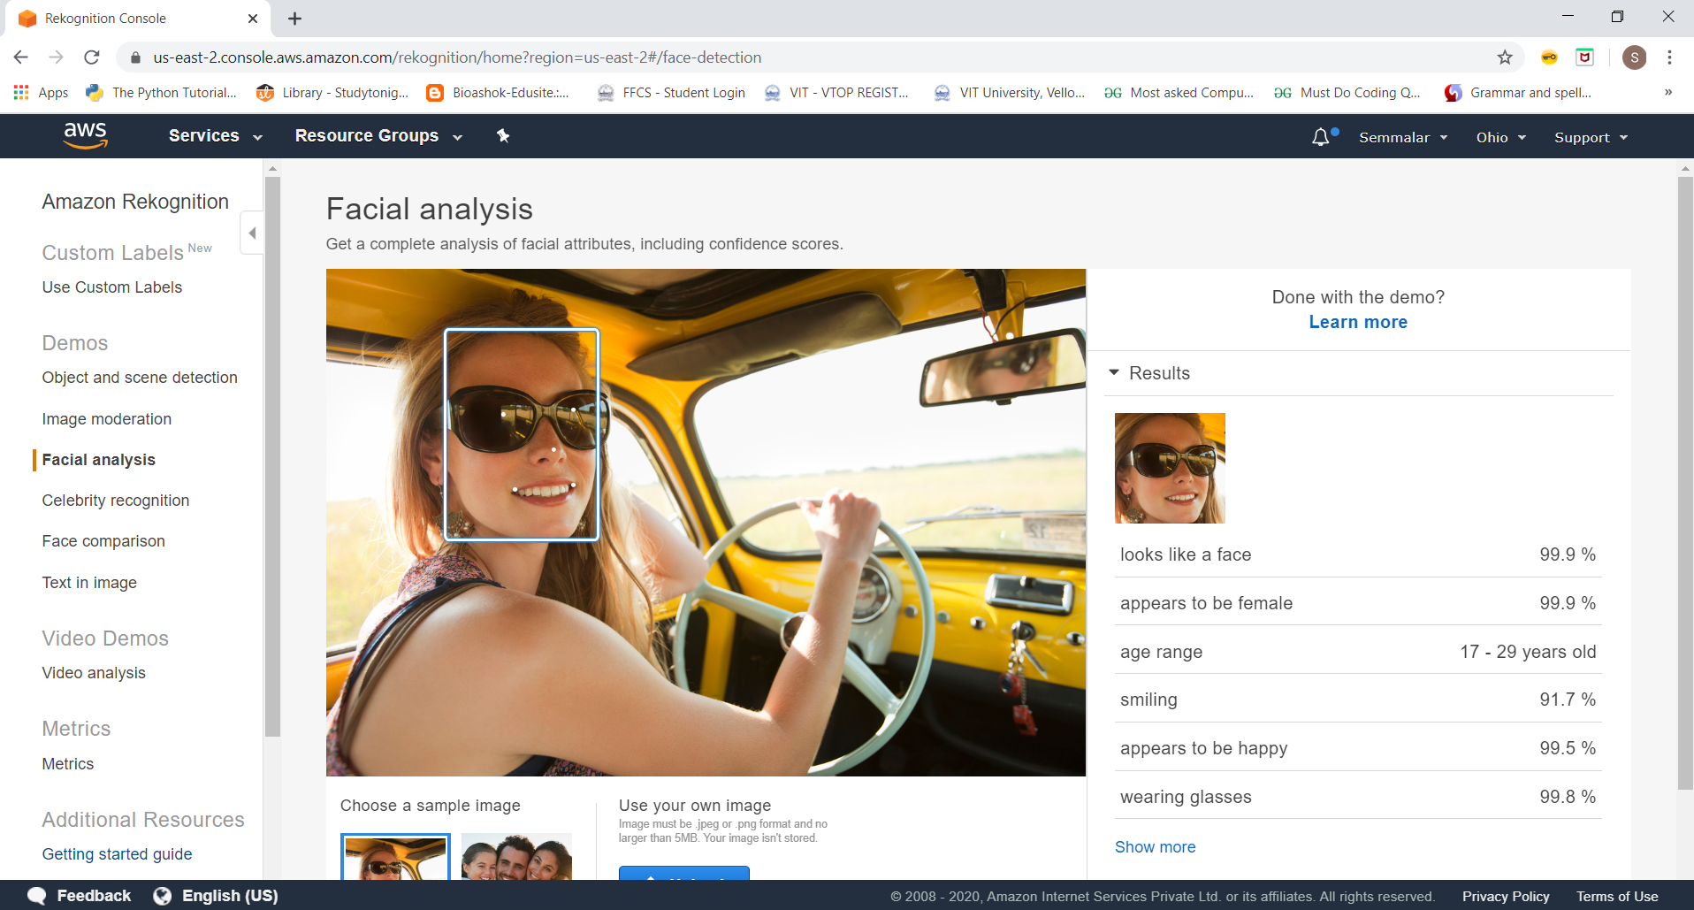

**Face Compare**

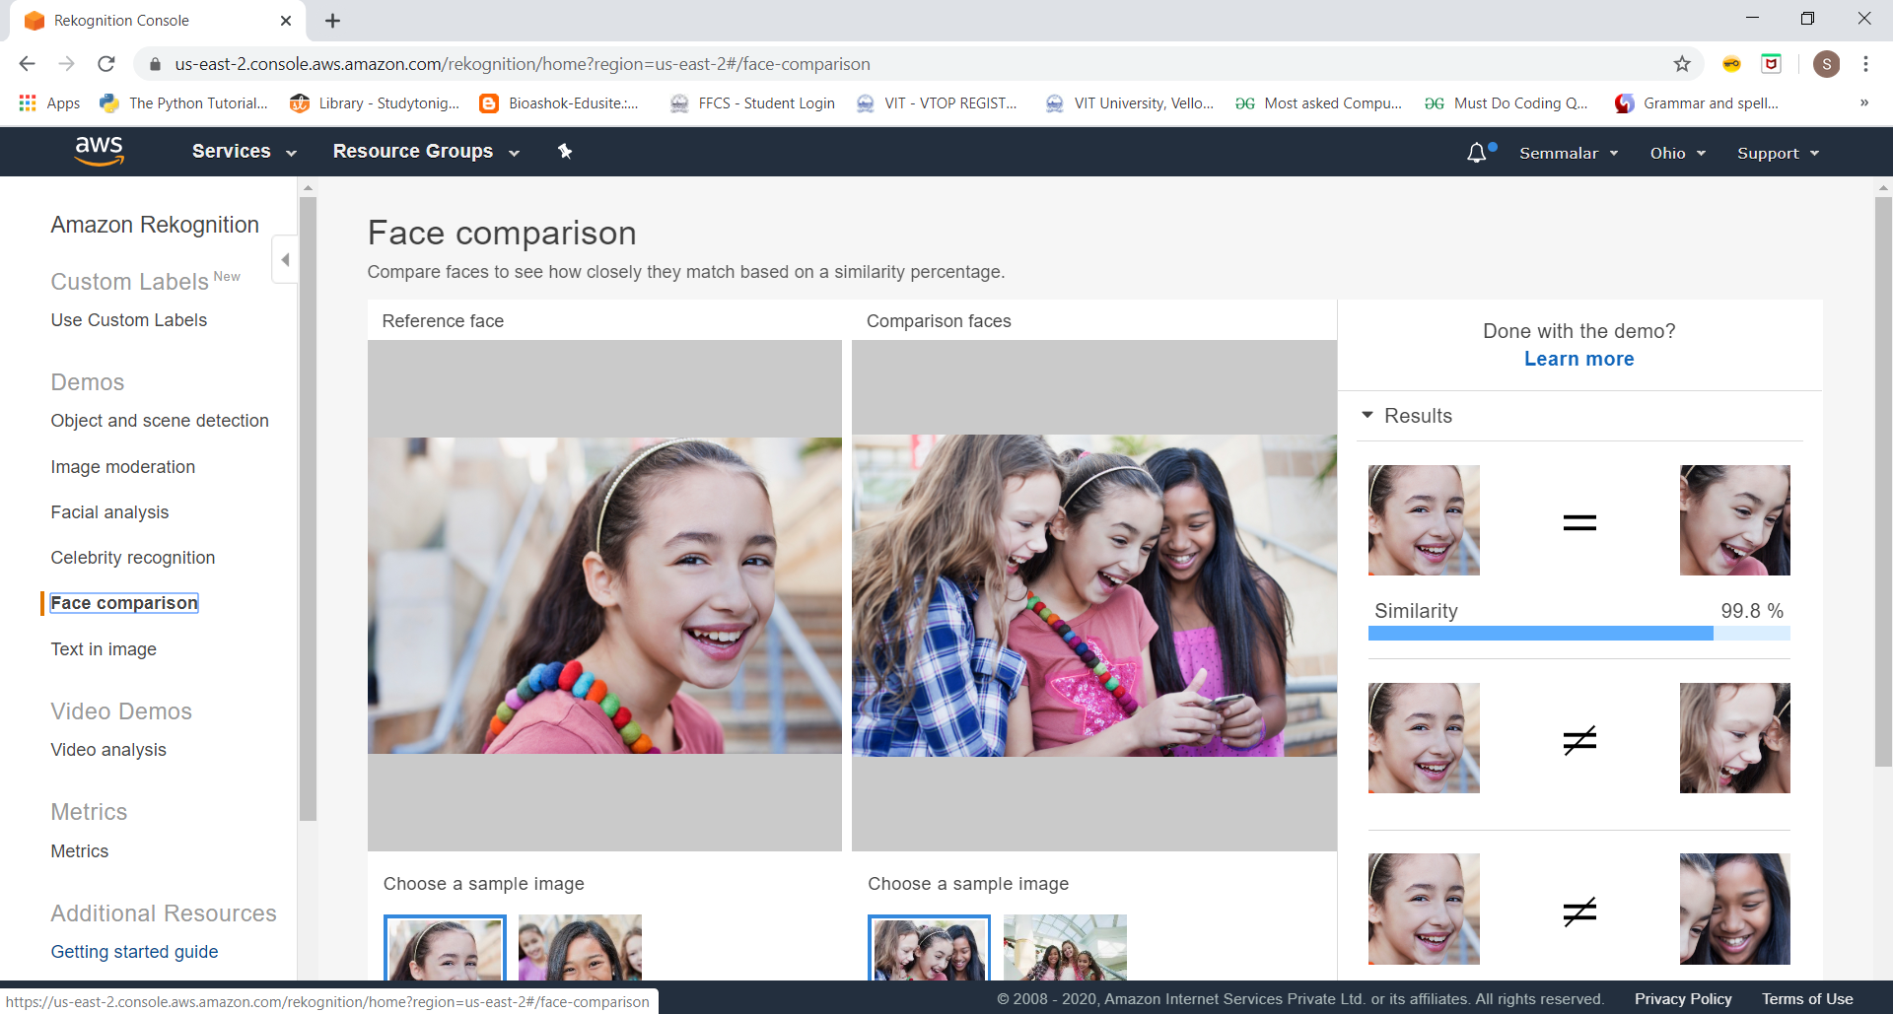

**Celebrity Recognition**

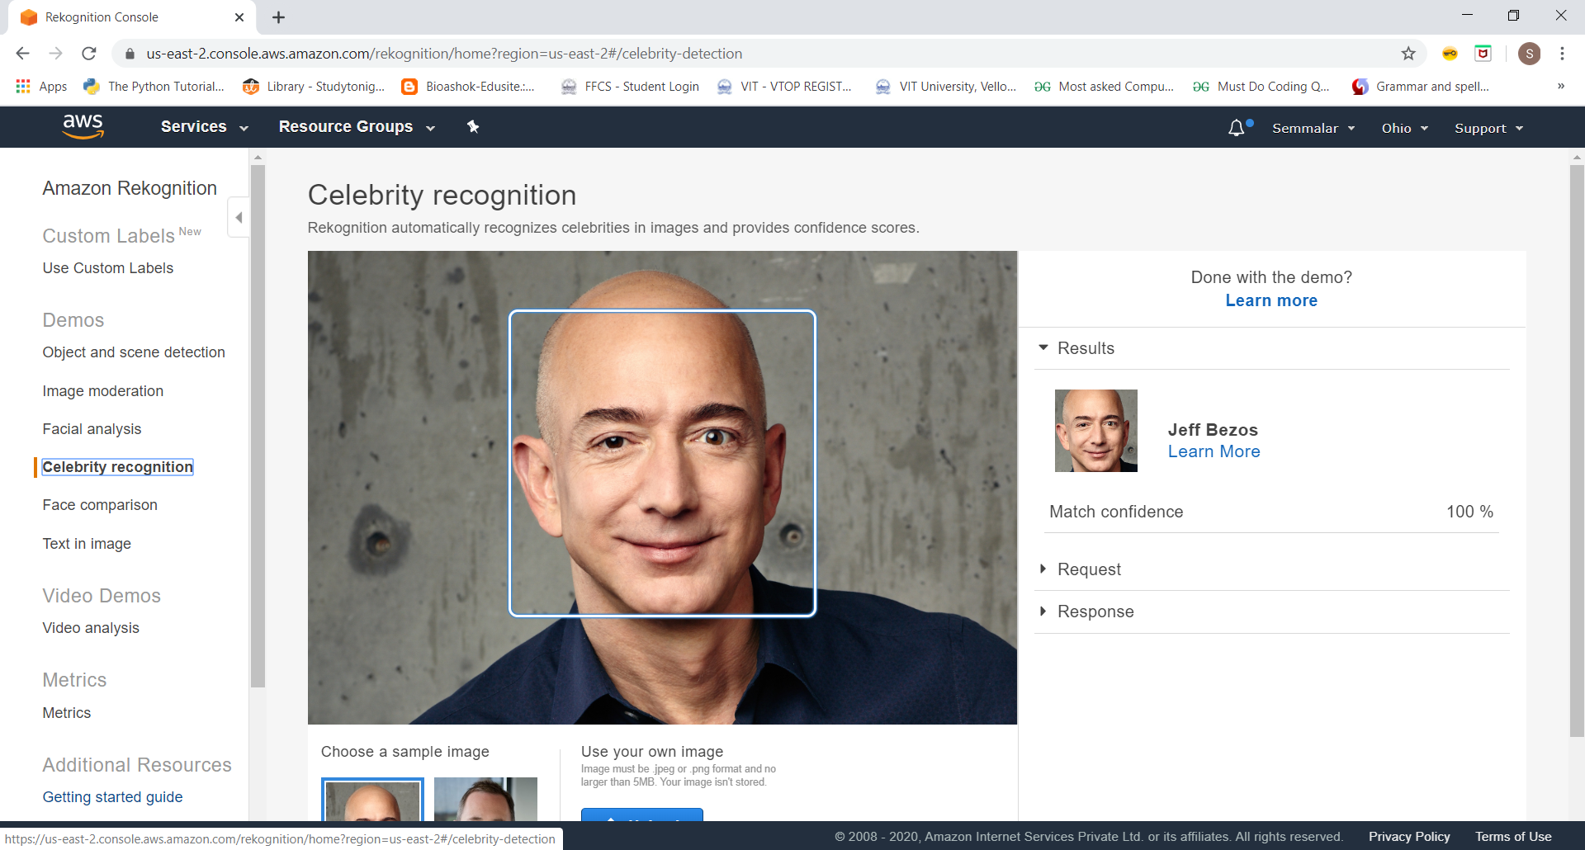

**Text in Image**

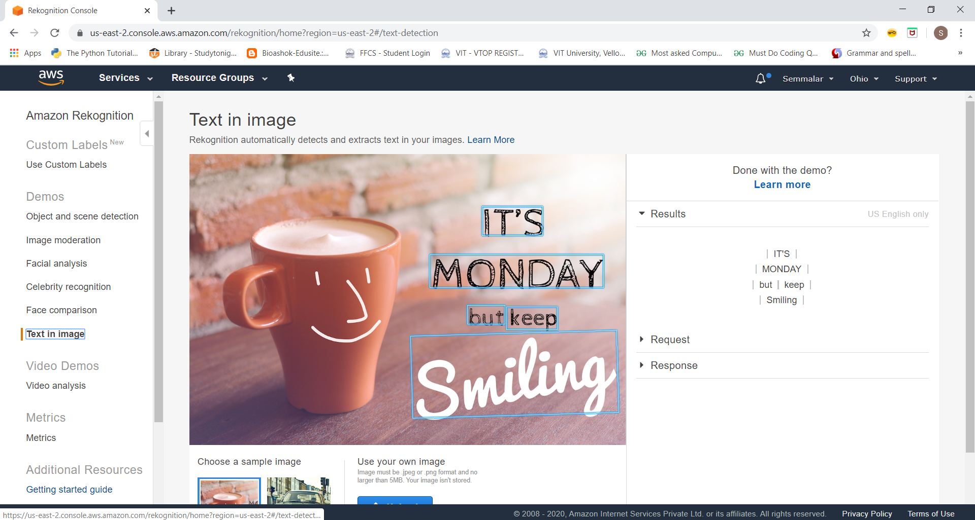

**SCREENSHOT NEEDED FOR EC2 AND S3**

**Installing aws-sdk**

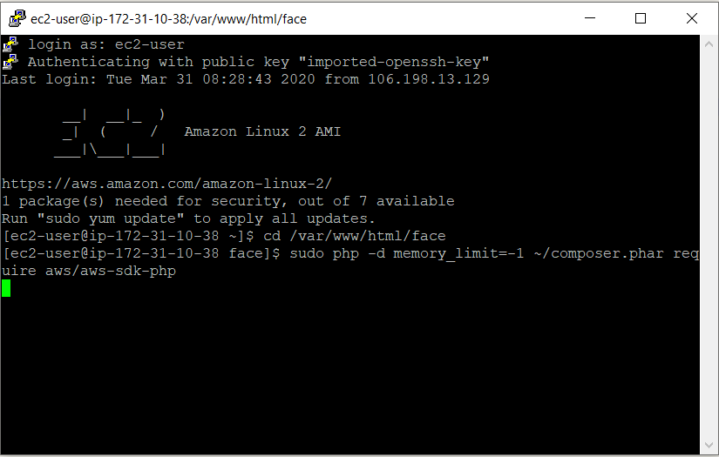

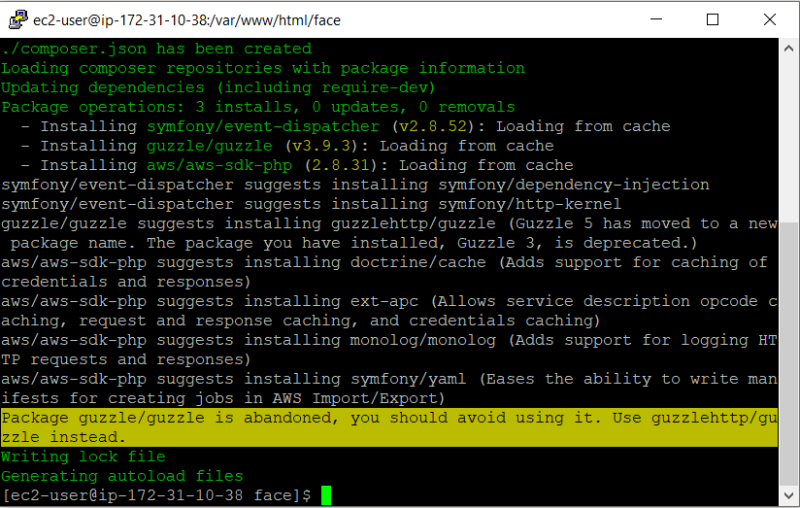

**Installing php**

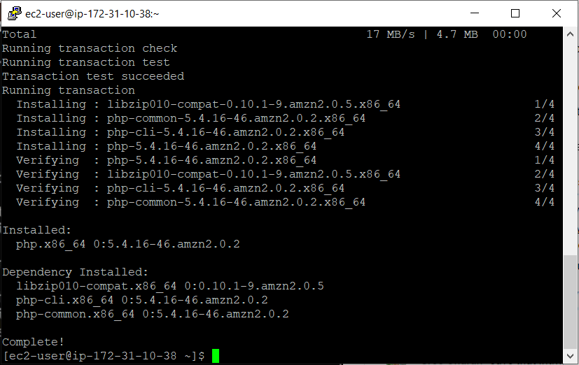

**index.php ﬁle code**

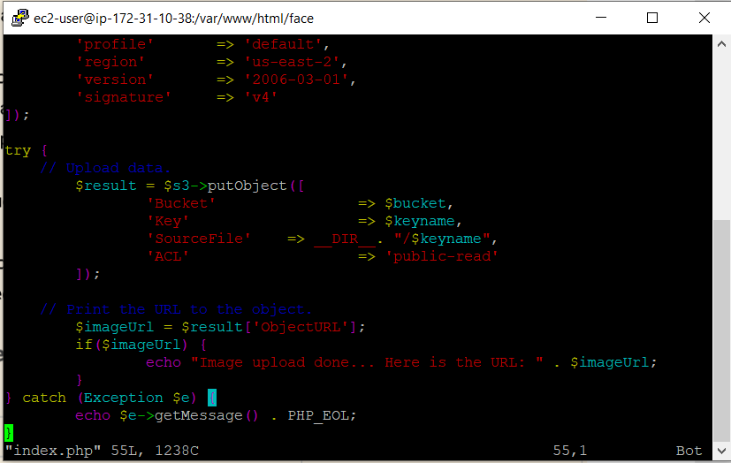

**Upload success screenshot**

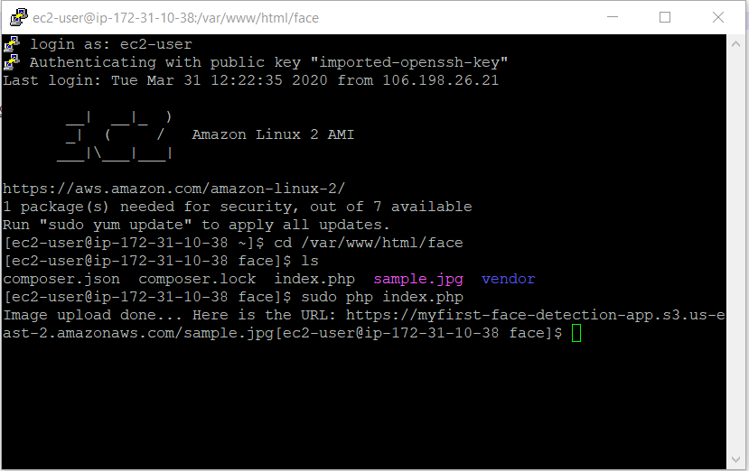

**SCREENSHOTS NEEDED FOR EC2 & REKOGNITION**

**Face Detect success screenshot**

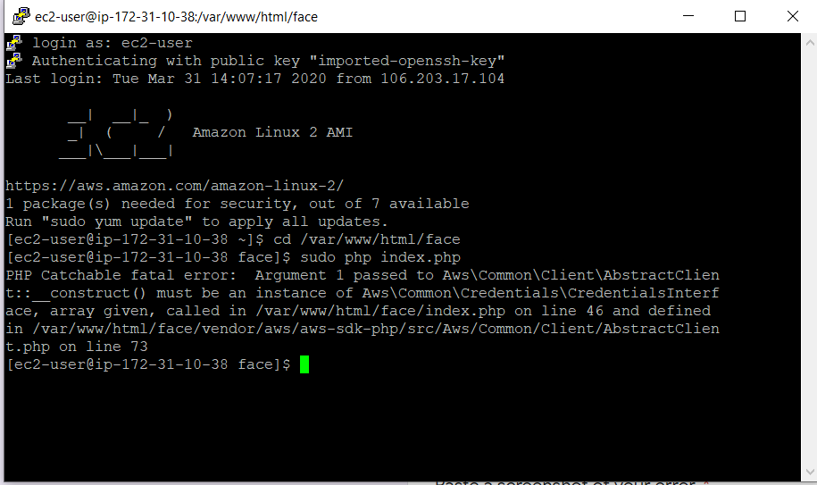

Sir,I am getting this error. I asked my query on the google form provided by Ethnus. It said in troubleshoot guide I will get some guide on the error. But no response was given. I don’t know how to resolve this error.